BUKTI KORESPONDENSI
ARTIKEL JURNAL AKREDITASI SINTA 5

Judul artikel Jurnal
: The Analysis of Wonderful Indonesia Logo: Charles Sanders Peirce's Triadic Theory

: e- Jounal Linguistics , volume 15 (2), 226 - 232

Penulis : Indah Kusumarini

No. | Perihal | Tanggal
1. | Bukti konfirmasi submit artikel dan respon | 23 Januari 2021
2. | Bukti perbaikan Artikel dari Reviewer | 21 Februari 2021
3. | Bukti konfirmasi artikel published online | 7 Juli 2021

1.Bukti Konfirmasi Submit Artikel
(23 Januari 2021)
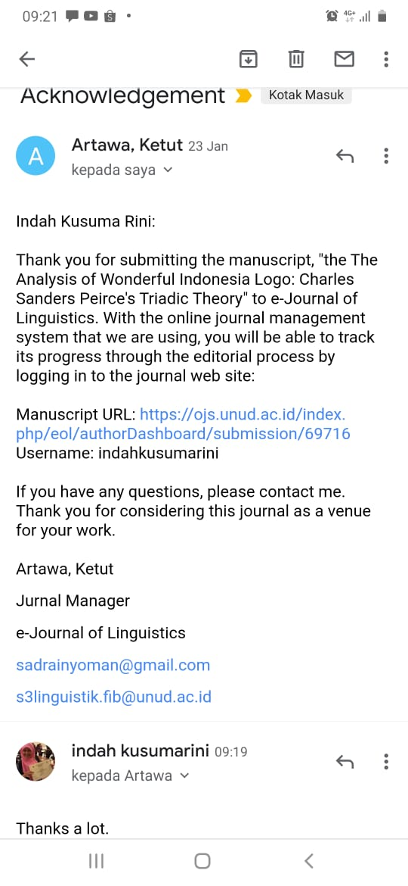

Bukti Perbaikan Artikel dari Reviewer
(21 Feb 2021)

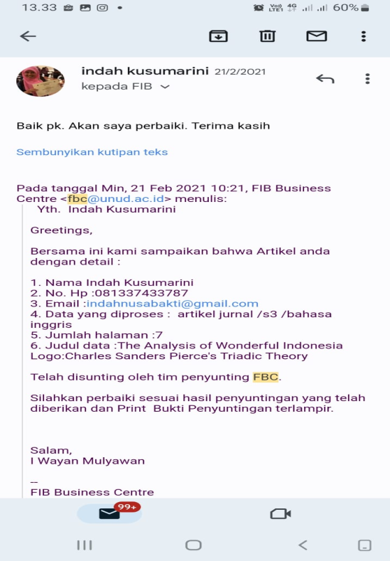

The Analysis of Wonderful Indonesia Logo: Charles Sanders Peirce's Triadic Theory

Indah Kusumarini,
Politeknik Pariwisata Bali, Nusa Dua, Indonesia. email:indahnusabakti@gmail.com

Article info |  | Abstract*
Received Date:  Accepted Date:  Published Date:  Keywords:*  Triadic, Representamen, Object, Interpretation, Language Function. |  | The Wonderful Indonesia logo is an Indonesian tourism identity formed by verbal and non-verbal elements. The verbal element is the words "wonderful Indonesia" and the non-verbal element is a picture of "bird" such as the eagle which is a symbol of the Indonesian state. Charles Sanders Peirce's Triadic theory mentions three main elements that make up the Wondeful Indonesia logo, namely: object, representation and interpretant.  The representation is expressed in the written language of “wonderful Indonesia” with artistic writing, flexible, elegant and beautiful fonts. It is interpreted that Indonesia is one of the world's most beautiful, charming and enchanting tourist destinations. The writing of "Indonesia" is bigger than the word “wonderful” so that it is interpreted that Indonesia is the one that has a variety of charms.  The object, in the form of a bird image, is like a Garuda. The head, wings, tail and body of the bird are displayed with flexible, beautiful, artistic lines, reflecting that Indonesians have a flexible, friendly, peace-loving character and are welcome to the world community.  The word "wonderful" is written in English as the language of the world's friends. It is hoped that this word which has a great, amazing, enchanting meaning can hit the minds of world citizens. Based on the function of language, the word "wonderful" has a poetic function, which is a message to be conveyed to the world, that Indonesia is very charming, amazing, unique and interesting.

1. Introduction
Communicating in digital era is very easy and more efficient because it is supported by adequate media such as whatsApp, internet, facebook, instagram, twitter and so on. In promoting goods or services, it is sufficient to take advantage of communication media such as advertisements, both in printed and electronic form. Advertising is a persuasive communication medium designed in such a way as to achieve response and marketing objectives. An advertising activities must be more than just providing information about the products offered to consumers, but also changing consumer attitudes.
In an effort to promote a tourist destination, advertisements are also needed. As was the case in promoting Indonesian tourism to the internal and the outside world with digital media so that it was easily accessible to foreign countries. Moreover, Indonesia's panoramic beauty video has won the best video at the Asia Pacific level in 2017. The tourism branding “Wonderful Indonesia” which was launched since 2011 has been recognized at the world level. It is one thing to be proud of, which has raised Indonesia to the world level. To popularize Indonesian tourism, the government through the Ministry of Tourism, in addition to creating the branding, also published the Indonesian tourism logo. (See figure.1)
Historically, the tourism branding “Wonderful Indonesia” logo related to the development of semiotic science is very dynamic, this is evident from the beginning of the emergence of semantic theory by Saussure to the triadic theory proposed by Peirce. According to Peirce, semiotics is based on logic, because logic studies how people reason, while reasoning according to Peirce is done through signs. Signs allow us to think, relate to other people and give meaning to what the universe represents. Peirce focused on the general functioning of the sign. According to Peirce, signs are related to the objects that resemble them. Their existence has a causal relationship with signs or because of conventional ties to these signs. In effect, Peirce has created a general theory for signs.
Then, one of the implementation of Peirce theory in the Wonderful Indonesia (WI) and Pesona Indonesia logo is as Indonesia's tourism identity which is often found on public transportation, such as being installed on tourist bus, trains and airplanes bodies. How was the use of signs or language expressions stated in the Wonderful Indonesia (WI) logo in both print and electronic media? For this reason, sign science or semiotics was used as a basis or reference in analyzing the Wonderful Indonesia (WI) logo.
Furthermore, there were several explanations about semiotics related to logos such as Kusrianto, Adi (292: 232) who stated that a logo or picture mark is an identity used to describe the image and character of an institution, product or company or organization. A logotype or word mark is the name of an institution, company, or product that appears in a special written form to describe its commercial characteristics.
Then, logos are usually used in the form of products developed by an institution, company and organization, as explained by John Murphy and Michael Rowe (2000) who argued that every successful product or organization has its own personality. and the complex human personality, as well as the product and organizational personality. Trademarks and logos of products and organizations are the appearance of a complex reality abbreviated into a simple statement; something that can be controlled, modified, developed and matured at any time.
Based on the above review, this article discusses Peirce's theory in examining the meaning contained in the Wonderful Indonesia logo. According to Sebeok (2001), the basis for circumscribing an autonomous field of inquiry that seek to understand the structures that undergird both the production and interpretation of Signs. Besides, Yakin & Totu (2014) explained that the main principles containing Peirce’s theory were the human mind and sign boundaries, the three-dimensional system (triadic), and the relativity regarding the three typologies or taxonomies of signs (icon, index, and symbol). Meanwhile, Sarpavaara (2013) explained that a Sign, or Representamen, is a First which stands in such a genuine triadic relation to a Second, called its Object, as to be capable of determining a Third, called its Interpretant, to assume the same triadic relation to its Object in which it stands itself to the same Object. So, the objectives of the study are the following:
- How is the implementation of the Peirce Triadic model of semiotic theory in the Wonderful Indonesia logo?
- What is the meaning of the sign in the Wonderful Indonesia logo?
- What is the language function contained in the Wonderful Indonesia logo?

2. Research Methods
This research applied a descriptive qualitative method. According to Moleong (2014), qualitative research is research in a special natural context by utilizing various natural methods that intend to understand the phenomena of what the research subject is experiencing and the way of description in the form of words and language. Furthermore, qualitative research is used by researchers intending to examine something in-depth and to examine the background, for example about motivation, roles, values, attitudes, and perceptions (Moleong, 2014). Then, the qualitative method is implemented to investigate, discover, describe, and explain the quality or features of social influence that cannot be explained, measured, or described through a quantitative approach (Wayan & Tista, 2020). This research is qualitative since it is concerned with non-numerical data and describing the facts of the analysis systematically based on what they actually are. The instrument of this research is document. According to Creswell (2012), documents consist of public and private records that qualitative researchers obtain about a site or participants in research, and they can include newspapers, minutes of meetings, personal journals, and letters. The data of this study are the covers in Wonderful Indonesia” that is related to topics about the government through the Ministry of Tourism, which in addition to creating the branding, also publish the Indonesian tourism logo. The researchers selected only one cover as data to be analyzed in this research. It was launched since 2011 in ASEAN International forum of the Ministry of Tourism in Cambodia, 17-18 January 2011. After selecting the data, the researchers analyzed the data using Peirce's triadic theory model with reference to triadic terms: representation, interpretant and object. After analyzing the data, the researchers provided results and discussion.
3. Discussions
The Wonderful Indonesia logo is an advertisement in promoting Indonesian tourism as a foreign tourist destination, both for the local tourists and foreign tourists. For the local level, this logo is often found on public transportation such as on the body of the buses, trains, airplanes and public boards so that it can be seen by many people. Meanwhile in other countries, as a promotional strategy for Indonesian tourism, this logo together with display images or videos of Indonesian tourism objects are installed on the railways, buses and billboards, digital screens, in crowded public places, such as stations, highways, airports and others.

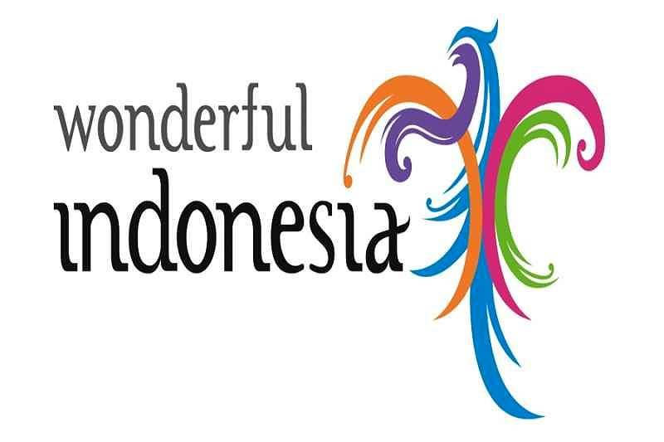

Figure 1. a figure logo of WI

The result of analysis is discussed as follows.
3.1. The Analysis of the Elements Forming the Wonderful Indonesia Logo
The semiotic theory of the Peirce’s triadic model is used in data analysis in this research. The researcher provides a description of the data on the elements related to the wonderful Indonesian logo, including verb and non-verb elements. Verbal elements in the form of the writing of wonderful Indonesia. The word wonderful has a lexical meaning as a good and beautiful thing, while Indonesia is the name of a country known as a country with thousands of islands.
Non-verbal elements, in the form of a bird image, wings with flexible lines in green, blue, purple, orange, and magenta colors. This non-verbal element shows a sign meaning that still refers to reprensetamen and interpretation, if not connected, this non-verb element has no meaning. Then, the data can be overviewed in Peirce's triadic analysis model. For more details, it can be seen in Figure 2 as follows;

Interpretant
(a beautiful description of the charm of nature, culture
and everything that Indonesia has)

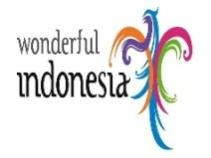

Representament Object
(writing: Wonderful Indonesia) (Wonderful Indonesia logo + bird image)
Figure 2. a figure of Implementation of
Charles Sanders Peirce’s Triadic Theory

3.2. The Analysis of Representament of Wonderful Indonesia
The expression of the language used in the Wonderful Indonesia advertisement is by using written language, namely Wonderful Indonesia with artistic writing. The letters are flexible, beautiful and captivating. The word Indonesia is bigger than the word Wonderful. This shows that Indonesia has a unique and diverse natural and cultural charms that is different to Malaysia or Singapore.

3.3. The Analysis of Interpretant of Wonderful Indonesia
Apart from the representament in the semiotic theory of Peirce's triadic model, the interpretant part is seen in terms of concepts or meanings that are understood by people in understanding a form of language itself, both conventional and arbitrary. In connection with all these things, the researcher analyzes the data by looking at the interpretant aspect of the language expression itself. For more details, the researcher describes matters related to the interpretation of the advertising data of Wonderful Indonesia. The discussion of the Interpretant analysis is shown below.
3.3.1. The Interpretation of Signs (Icons, Indexes, Symbols)
The symbol a bird spreaded its wings indicates the ability to fly beyond limits. Being able to present a desire beyond borders, for the purpose of achieving dreams and hopes for the development of Indonesia's tourism in around the world.
3.3.2. The Interpretation of Meanings
The interpretation of meaning is classified into: first the word Wonderful Indonesia, second the outline of the bird's wings and body, and third the five colors in logo. The explanation of each items is in the following:
3.3.2.1. The Word Wonderful Indonesia
It shows that Indonesia is an amazing world tourist destination from all aspects, which makes someone curious to see, enjoy, adventure with natural charm, cultural diversity, customs, community life and everything that Indonesia has.
3.3.2.2. The Outline of the Bird's Wings and Body
It is interpreted as the flexible lines reflecting the flexibility of the Indonesian people character, i.e. friendly and welcoming.

3.3.2.3. The Five Colors in Logo
It reflects Indonesia's diversity such as nature, culture and ethnicity, culinary arts, society and others. According to Nugroho (2008: 37-38) color has its own meaning:
1. Green: natural beauty, freshness, peace and relaxing effect
2. Purple: faith, live in peace
3. Orange: warmth, comfort, familiarity
4. Blue: broad, shade
5. Magenta: physical mental balance (emotional)

3.4. The Analysis of the Object of Wonderful Indonesia Logo
The analysis of the objects on the wonderful can be seen in the wonderful Indonesia logo and the colorful bird image on its wings and body. All these things show that there are relationship between interpretants and representants which illustrate that the logo itself has meaning in accordance with the previous references, both the representative and the interpretant. So that in the object of the meaning of the sign, both the meaning of colorful bird images imply that the color indicates that a situation in the state of tourist destinations in Indonesia is very diverse and has its own uniqueness, both in terms of cultural, religious and natural tourism. All these things have been reflected by the provision of various colors in the wonderful object or logo, which illustrates the shape of the bird image.

3.5. The Analysis of the Language Function in Logo
In the Wonderful Indonesia logo, the word wonderful is deliberately written in English as the world's language. It is hoped that this word which has a great, amazing, enchanting meaning can easily come to the mind of the world’s citizens. This is in accordance with the language function conveyed by Jakobson, namely the Poetic function. There is a message to be conveyed to the world, that Indonesia is very charming, amazing, unique and interesting.
From the word wonderful, it will bring someone to imagine the beauty and charm of Indonesia's panoramic views, causing curiosity and ultimately wanting to travel to Indonesia. The Conative function plays a role in this context, which is to cause reactions to the interlocutor or speaker (addressee) to do something. The word Indonesia is bigger than the word wonderful. There is a message to convey that it is Indonesia that is charming, not Malaysia, Singapore or other neighboring countries.

4. Novelties
Referring to Piliang (2010: 266-267) that the semiotic theory of Peirce's triadic model, where Peirce's triadic model shows the three main elements forming a sign, namely representamen (something that represents something else), object (something that is represented) and interpretant (one's interpretation of signs), it is found that in advertisement of Wonderful Indonesia tourism promotion which is the conative function of language in Peirce theory plays an important role to represent the condition of the country.

5. Conclusion
The phrase of Wonderful Indonesia logo is an Indonesian tourism brand that was launched in 2011 to replace Visit Indonesia. From the semiotic analysis, the Wonderful Indonesia logo is formed by verbal and non-verbal elements. The verbal element is in the form of the words "wonderful Indonesia” and the non-verbal element is in the form of a picture of bird such as the eagle which is a symbol of the Indonesian state. The head, wings, tail, body of the bird are displayed with flexible lines, beautiful, artistically colored in green, blue, purple, orange, magenta colors. It reflects that Indonesian people have a character that is flexible, friendly, peace-loving, and welcome to the world community. The whole part of the bird is given various colors. This is intended to provide an illustration that Indonesia is an archipelago that has diversity, nature, culture, and the life of its people with distinctive customs and coexistence with adherents of different religions.
The representament analysis expressed in the written language of wonderful Indonesia with artistic writing, flexible, elegant and beautiful fonts reflects that Indonesia is one of the world's beautiful, charming, captivating and enchanting tourist destinations. The word Indonesia is bigger than the word wonderful. This shows that Indonesia has a diversity of charms, not Malaysia, Singapore or other neighboring countries.
The word wonderful is deliberately written in English as the language of the world. It is hoped that this word which has a great, amazing, enchanting meaning can hit the minds of world citizens. Based on the function of language, the word wonderful has a poetic function, which is a message to be conveyed to the world, that Indonesia is very charming, amazing, unique and interesting.
From the word wonderful, it will bring someone to imagine the beauty and charm of Indonesia's panoramic views, causing curiosity and ultimately wanting to travel to Indonesia. The conative function plays a role in this context, namely causing reactions to the interlocutor or speaker (addressee) to do something.

6. Acknowledgements
The researcher would like to thank and appreciate those who have contributed to this current study, especially to Suparman for the translation.

References
Creswell, John, W. (2012). Educational research: planning, conducting, and evaluating quantitative and qualitative research. United State of America: Pearson Education, Inc.
Kusrianto, Adi. (2009). Introduction to Visual Communication Design. Yogyakarta: Publisher Andi.
Moleong, Lexy J.(2014). The Qualitative Research Revise Edition: Bandung Remaja Rosdakarya.
Murphy, John and Michael Rowe. (2000). How to Design Logos, Symbol and Icons. Ohio : North Light Books.
Nugroho, Eko. 2008. Pengenalan Teori Warna. Yogyakarta: Penerbit Andi.
Peirce.C.S. 1998. Principles of Philosophy, Volume I, Ed: Charles Hartshorne & Paul Weiss, Colected Papers of Charles Sanders Peirce. England : Thoermmes Press.
Piliang, Yasraf Amir. 2010. Hipersemiotika: Tafsir Cultural Studies atas artinya Makna.Yogyakarta: Jalasutra.
Sarpavaara, H. (2013). A Peircean analysis of counselors’ interpretations and clients’ responses in motivational interviewing sessions. Social Semiotics, 23(1), 67–82. https://doi.org/10.1080/10350330.2012.693297.
Sebeok, T. (2001). Signs: An Introduction to Semiotics (Toronto Studies in Semiotics and Communication). University of Toronto Press.
Wayan, N., & Tista, K. (2020). Process Types of Transitivity System in The Ritual Teks of Tawur Sasih Kesanga in Desa Adat Kuta. E-Journal of Linguistics, 14(2), 257–267.
Yakin, H. S. M., & Totu, A. (2014). The Semiotic Perspectives of Peirce and Saussure: A Brief Comparative Study. Procedia - Social and Behavioral Sciences, 155(October), 4–8. https://doi.org/10.1016/j.sbspro.2014.10.247.

Biography of Author
Indah Kusumarini is a Japanese lecturer in Politeknik Pariwisata Bali, Indonesia. She graduated from Japanese Language Program in Surabaya University, East Java, Indonesia in 1996. She obtained her Master Degree in Tourism from Udayana University, Bali, Indonesia in 2007. She is currently a doctorate candidate in Linguistics at Udayana University and her main research is focused on Linguistic Pragmatic.
Email: indahnusabakti@gmail.com

Bukti Artikel di Publish
( 7 Juli 2021)

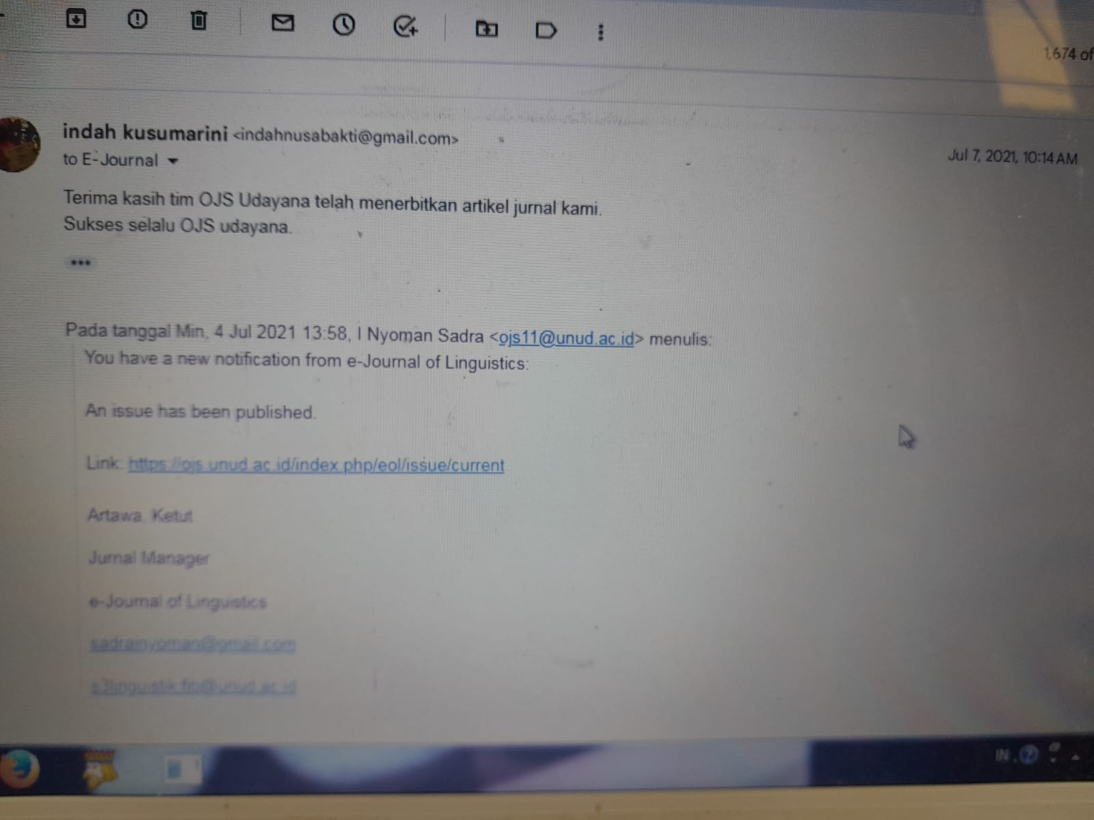
8/1/2020 Gmail - Journal of Psychoeducational Assessment - Manuscript ID JPA-18-0139

Journal of Psychoeducational Assessment - Manuscript ID JPA-18-0139

Journal of Psychoeducational Assessment <onbehalfof@manuscriptcentral.com> Tue, Jun 26, 2018 at 12:23 PM Reply-To: JPA@sagepub.com
To:

26-Jun-2018

Dear Dr. :

Your manuscript entitled
for Higher Education Academics"

has been
successfully submitted
"Development and Initial Validation of Perceived Research Environment Scale

online and is presently being given full

consideration for publication in Journal of Psychoeducational Assessment. Your manuscript ID is JPA-18-0139.
Please mention the above manuscript ID in all future correspondence or when calling the office for questions. If there are any changes in your street address or e-mail address, please log in to ScholarOne Manuscripts at https://mc.manuscriptcentral.com/jopa and edit your user information as appropriate.

You can also view the status of your manuscript at any time by checking your Author Center after logging in to https://mc.manuscriptcentral.com/jopa.

As part of our commitment to ensuring an ethical, transparent and fair peer review process SAGE is a supporting member of ORCID, the Open Researcher and Contributor ID (https://orcid.org/). We encourage all authors and co- authors to use ORCID iDs during the peer review process. If you already have an ORCID iD you can link this to your account in ScholarOne just by logging in and editing your account information. If you do not already have an ORCID iD you may login to your ScholarOne account to create your unique identifier and automatically add it to your profile.
Thank you for submitting your manuscript to Journal of Psychoeducational Assessment. Sincerely,
Journal of Psychoeducational Assessment Editorial Office

